1. Project Selection & Team Formation
The project selected for this course is “CreditBridge: Inclusive Credit Card Processing System.”
The project aims to address the "cold start" problem in banking by creating a secure, automated system that processes credit card applications, verifies identity, and monitors transactions, featuring a specialized scoring engine for applicants with no credit history.
This project was chosen because it solves a real-world financial inclusion problem using software engineering principles and demonstrates the practical application of secure data handling, complex decision logic, and system architecture design.

Team Formation and Assigned Roles
To ensure systematic development and effective collaboration, the project team was formed with clearly defined roles and responsibilities as follows:
Team Member | Assigned Role | Responsibilities
Arbaz Khan | Project Manager | Project planning, task allocation, progress tracking, and coordination among team members.
Sagnik Roy | Lead Developer | Core logic implementation (Scoring Engine), database design, and API development.
Imad Ahmed | QA Lead | Requirement verification, testing (Unit/Integration), security auditing, and validation of system design.
Kumar Samarth | Documentation Lead | Preparation of SRS, design documents, reports, and maintaining documentation consistency.

These roles ensure clear accountability, efficient workflow, and timely completion of the CreditBridge project.

2. Team Agreement Creation
A team agreement was created to define working norms, responsibilities, and collaboration rules for the development of the CreditBridge system.
This agreement ensures smooth teamwork, accountability, and effective communication throughout the project lifecycle.
Team Working Norms
- All team members will actively participate in project-related activities.
- Tasks will be distributed equally among team members.
- Regular discussions will be conducted to track progress.
- All decisions will be made collectively by the team.
- Any issues or conflicts will be resolved through mutual discussion.
Communication Guidelines
- Team members will communicate through regular meetings and online platforms (Slack/WhatsApp).
- Important updates and changes will be shared with all members immediately.
- Deadlines will be respected and followed strictly.
Quality and Responsibility Agreement
- Each member is responsible for completing assigned tasks on time.
- Work submitted by any member will be reviewed by at least one other member.
- The team agrees to maintain academic honesty and originality.
This team agreement was accepted by all members to ensure disciplined, collaborative, and efficient project execution.

3. Problem Statement Development
Project Title: CreditBridge: Inclusive Credit Card Processing System
Problem Description: Traditional credit card processing systems are often inefficient and exclusionary. They rely heavily on manual verification, leading to slow turnaround times (days or weeks) and high processing costs. More critically, existing software depends almost exclusively on historical credit scores (like CIBIL or FICO). This creates a "credit paradox" where students and young professionals cannot get a credit card because they lack a credit history, but cannot build a history without a card. Consequently, millions of financially viable individuals are automatically rejected by standard algorithms.
Proposed Solution: The proposed CreditBridge is a secure, web-based system designed to automate the entire credit card lifecycle—from application to transaction monitoring. The key innovation is a Hybrid Decision Engine. The system first checks for a traditional credit score; if the score is absent (null), it triggers an "Alternative Scoring" module that analyzes the applicant's financial potential based on income stability and cash flow (simulated bank statement analysis). This allows the system to approve entry-level cards for new-to-credit users securely.
Target Users:
- Applicants: Students, young professionals, and immigrants with no credit history seeking their first card.
- Bank Administrators: Staff managing risk, approving flagged applications, and monitoring system health.
- Merchants: Entities initiating payment transactions (simulated).
Value Proposition: CreditBridge adds significant value by reducing processing time from days to seconds through automation. It promotes financial inclusion by providing a fair assessment for users with no credit history, while ensuring the bank maintains rigorous control over risk and fraud through real-time transaction monitoring.

4. Stakeholder Analysis
Stakeholder analysis involves identifying individuals or groups who have an interest in or are affected by the CreditBridge system.
These stakeholders are categorized as primary and secondary based on their level of direct involvement with the system.
Primary Stakeholders:
- Applicants (End Users): Individuals applying for credit cards. They use the system to submit data, upload documents, and view their application status. Their main interest is fast approval and a user-friendly interface.
- Bank Administrators: Staff who use the dashboard to oversee the system, handle manual overrides for flagged applications, and view transaction logs.
- Merchants: External entities (stores/websites) that initiate transactions using the issued cards.
Secondary Stakeholders:
- Bank Management: Senior management benefits from the increased customer base (financial inclusion) and reduced operational costs.
- IT Security Team: Responsible for ensuring the encryption of sensitive user data (PII) and maintaining system uptime.
- Regulatory Authorities: Concerned with compliance to financial laws (KYC/AML) and fair lending practices.

5. Stakeholder Interests Documentation
Stakeholder interests documentation identifies the expectations, needs, and level of influence of each stakeholder involved in the CreditBridge system.
Stakeholder Interests and Influence
- Applicants:
  - Interests: Fast decision on application, data privacy, clear reasoning for rejection.
  - Influence: Medium – Feedback affects system adoption.
- Bank Administrators:
  - Interests: Accurate risk assessment, efficient workflow for manual reviews, easy-to-read dashboards.
  - Influence: High – Daily users and controllers of the system.
- Bank Management:
  - Interests: Market expansion, low default rates, operational efficiency.
  - Influence: High – Provides strategic direction and funding.
- IT Security Team:
  - Interests: Data integrity, prevention of breaches, secure transaction protocols.
  - Influence: Medium – Maintains system security standards.
- Regulatory Authorities:
  - Interests: Compliance with banking norms, prevention of fraud/money laundering.
  - Influence: High – Sets the rules the system must follow.

6. Stakeholder Register Creation
The following table identifies the stakeholders, their roles, and interests:
Stakeholder | Role | Interests | Influence Level
Applicants | End Users | Fast approval, inclusive scoring, data privacy | Medium
Bank Administrators | System Operators | Efficient risk management, fraud monitoring | High
Bank Management | Sponsor | Customer growth, cost reduction | High
IT Security Team | Technical Support | Data encryption, system reliability | Medium
Regulatory Authorities | Oversight Body | Legal compliance, fair lending | High

7. Scope Definition - In-Scope
The in-scope features define the functionalities that are included in the CreditBridge system. These features are essential for the automated processing of credit cards.
In-Scope Features:
- User Registration & Application: Secure portal for users to input personal details, income data, and upload KYC documents.
- Hybrid Scoring Engine: An algorithm that calculates creditworthiness using either historical credit scores OR alternative cash-flow analysis (income vs. expenses).
- Card Issuance: Generation of unique, valid 16-digit card numbers (Luhn Algorithm), CVV, and expiry dates for approved users.
- Transaction Processing: Simulation of payments, checking balance availability, and updating the ledger in real-time.
- Fraud Detection: Basic logic to flag suspicious transactions (e.g., high value or location mismatch).
- Admin Dashboard: Interface for bank staff to view all applications, approve/reject flagged cases, and view transaction logs.

8. Scope Definition - Out-of-Scope
The out-of-scope features define the functionalities that are not included in the CreditBridge system to maintain clear project boundaries.
Out-of-Scope Features:
- Real Money Transfer: The system will not integrate with real banking payment gateways; funds are simulated.
- Physical Card Production: The logistics of printing and mailing physical plastic cards are excluded.
- External Bureau Integration: We will not connect to real credit bureaus (like CIBIL/Experian); a "Mock API" will be used.
- Mobile Application: The project is limited to a web-based interface; no Android/iOS app will be developed.
- Advanced AI Fraud Models: Complex machine learning models for fraud prediction are excluded; rule-based logic will be used.

9. Scope Boundaries Document
The scope boundaries define the limits of the CreditBridge system by clearly specifying what the system will and will not do.
Included Within Scope:
- Digital application submission and tracking.
- Automated decision-making based on defined logic.
- Database storage of user profiles and transaction history.
- Simulation of merchant payment requests.
- Role-based access control for Applicants and Admins.
Excluded from Scope:
- Handling of cash withdrawals (ATM features).
- Integration with core banking legacy systems.
- Biometric verification (Fingerprint/FaceID).
- Multi-currency support (System operates in a single currency).
System Boundaries:
- The system operates as a standalone web application.
- It acts as a processing layer and ledger but does not hold actual legal tender.

10. SRS Introduction Section
1. Purpose
The purpose of this Software Requirements Specification (SRS) document is to define the functional and non-functional requirements of the CreditBridge: Inclusive Credit Card Processing System. This document serves as a reference for developers, testers, and stakeholders to understand system behavior, features, and constraints.
2. Scope
The CreditBridge system is designed to automate the credit card application process and transaction monitoring. It replaces manual verification with a hybrid scoring engine to promote financial inclusion. The system manages the lifecycle from application to card issuance and simulated usage.
3. Definitions & Acronyms
Term / Acronym | Description
SRS | Software Requirements Specification
KYC | Know Your Customer (Identity Verification)
Pads | Potential Applicant Data Score (Alternative Score)
Luhn Algo | A checksum formula used to validate credit card numbers
Admin | Bank staff responsible for system oversight
CVV | Card Verification Value (Security Code)

11. SRS Overall Description
1. Product Perspective CreditBridge is a web-based application comprising a User Frontend (for applicants), an Admin Portal (for bank staff), and a Backend API connected to a secure relational database. It interacts with a "Mock Credit Bureau" to simulate external data fetching.
2. Product Functions The major functions of the system include:
- Secure user registration and login.
- Application form submission with document upload.
- Automated credit scoring (Historical + Alternative).
- Virtual card generation (Number, Expiry, CVV).
- Real-time transaction authorization.
- Fraud alert monitoring.
3. User Characteristics
- Applicants: Basic internet literacy; seeking financial products.
- Bank Admins: Trained in financial risk assessment and system management.
4. Constraints
- Must ensure strict data privacy (PII protection).
- Transaction processing must be atomic (ACID properties).
- Limited to simulated financial data for academic purposes.

12. Functional Requirements Documentation
FR-01: Application Submission
- Description: The system shall allow users to fill out an application form with personal and financial details.
- Acceptance Criteria: User can save and submit the form. System validates mandatory fields (PAN, Income).
FR-02: Hybrid Scoring Engine
- Description: The system shall calculate a credit score. If a traditional score is null, it must calculate an alternative score based on income/expense ratio.
- Acceptance Criteria: Applicants with no history but high "Financial Potential" are approved. High-risk applicants are rejected.
FR-03: Card Issuance
- Description: The system shall generate a unique credit card for approved users.
- Acceptance Criteria: Card number passes Luhn validation. CVV and Expiry are generated automatically.
FR-04: Transaction Processing
- Description: The system shall authorize or decline transactions based on available balance and card status.
- Acceptance Criteria: Balance is updated immediately after a successful transaction. Over-limit transactions are declined.
FR-05: Fraud Detection
- Description: The system shall flag suspicious transactions.
- Acceptance Criteria: Transactions over a specific threshold or from mismatched locations are flagged as "Suspicious" and require Admin review.
FR-06: Admin Review
- Description: The system shall provide a dashboard for manual review.
- Acceptance Criteria: Admin can view flagged applications/transactions and select "Approve" or "Reject".

13. Non-Functional Requirements Documentation
NFR-01: Security
- The system shall encrypt sensitive user data (passwords, card numbers) using standard encryption algorithms (AES/BCrypt).
- Acceptance Criteria: Passwords are not stored in plain text.
NFR-02: Performance
- The system shall process a transaction request in under 2 seconds.
- Acceptance Criteria: Instant feedback provided to the merchant/user.
NFR-03: Reliability
- The system shall ensure data consistency using database transactions (ACID).
- Acceptance Criteria: No partial transactions (money deducted but not credited) occur.
NFR-04: Availability
- The system shall be available 99% of the time during testing phases.
- Acceptance Criteria: Minimal downtime during demo.

14. Use Case Diagrams Creation
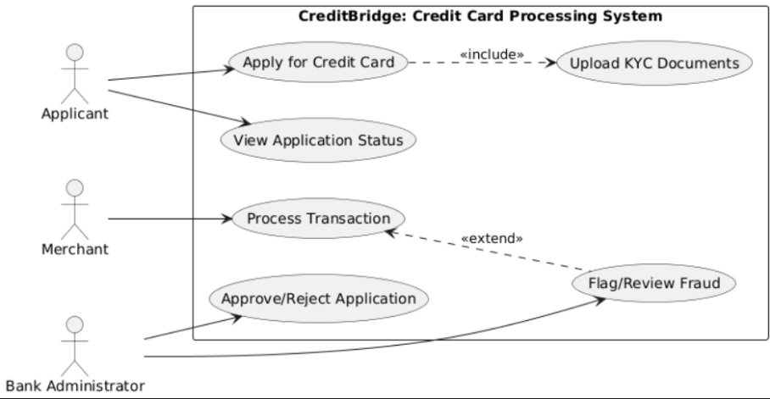
The use case diagram illustrates interactions between Applicants, Bank Admins, and Merchants with the CreditBridge System. It defines system boundaries and shows how each actor accesses specific functionalities.

15. Glossary Development
Term | Description
CreditBridge | The name of the software system being developed.
Applicant | A user applying for a credit card.
Credit Limit | The maximum amount a user is allowed to spend.
Transaction | An event where funds are deducted from the credit balance.
Merchant | A vendor or shop initiating a payment request.
Fraud Flag | A system alert indicating suspicious activity.
Hybrid Scoring | A logic that uses both credit history and cash flow for approval.
Dashboard | The interface used by Admins to monitor the system.

16. Project Charter
Project Title: CreditBridge: Inclusive Credit Card Processing System
Project Overview: CreditBridge is a software solution designed to automate credit card issuance and transaction management. It focuses on financial inclusion by utilizing a unique scoring algorithm for users without credit history.
Project Objectives:
- To automate the credit application and verification process.
- To provide credit access to unbanked populations via alternative scoring.
- To ensure secure and accurate transaction processing.
- To provide a real-time dashboard for risk monitoring.
Project Scope:
- Web-based Application Portal.
- Backend Scoring and Transaction Engine.
- Admin Dashboard for oversight.
- Exclusions: Real banking API integration, physical card printing.
Stakeholders:
- Applicants (End Users)
- Bank Administrators (Owners)
- Bank Management (Sponsors)
Project Deliverables:
- SRS Document
- UML Design Diagrams (Class, Sequence, Activity, etc.)
- Working Software Prototype
- Final Project Report
Risks:
- Complexity of fraud detection logic.
- Data security vulnerabilities during development.

17. Stakeholder Register Submission

The following table identifies the stakeholders, their roles, and interests:
Stakeholder | Role | Interests | Influence Level
Applicants | End Users | Fast approval, inclusive scoring, data privacy | Medium
Bank Administrators | System Operators | Efficient risk management, fraud monitoring | High
Bank Management | Sponsor | Customer growth, cost reduction | High
IT Security Team | Technical Support | Data encryption, system reliability | Medium
Regulatory Authorities | Oversight Body | Legal compliance, fair lending | High

The stakeholder register is reviewed and approved to ensure all relevant stakeholders are identified and their expectations are considered.

18. Complete Software Requirements Specification (SRS) Document
The Software Requirements Specification (SRS) document for the CreditBridge: Inclusive Credit Card Processing System has been prepared by consolidating all previously defined sections, including the problem statement, stakeholder analysis, scope definition, functional requirements, non-functional requirements, use case descriptions, and glossary.
The complete SRS document includes:
- Introduction and purpose of the system
- Overall system description
- Functional requirements (FR-01 to FR-06)
- Non-functional requirements (NFR-01 to NFR-04)
- Scope definition and boundaries
- Use case diagrams
- Glossary of terms
The SRS document follows standard software engineering practices and serves as a baseline reference for system design and development.

19. Requirements Sign-off
The requirements sign-off confirms that all stakeholders have reviewed and approved the requirements specified in the SRS document for CreditBridge.
Approved By: Name: ____________________ Role: ____________________ Signature: _______________ Date: ___________

20. CASE Tool Setup
For the design phase of the CreditBridge project, a Computer-Aided Software Engineering (CASE) tool was selected to create and manage system diagrams efficiently.
Selected CASE Tool: StarUML StarUML was installed and configured to support UML-based modeling. The tool is used to design Use Case, Class, Sequence, Activity, Component, and Deployment diagrams.

21. Team Workspace Setup
A dedicated workspace was created within the CASE tool environment to support collaborative design. Workspace Setup:
- Separate project file (CreditBridge_Design.mdl).
- Organized folders for specific diagram types (Behavioral, Structural).
- Naming conventions established for clarity.

22. Project Structure Creation
The project structure within the CASE tool was designed to logically organize all UML diagrams:
- Use Case View: Applicant, Admin, and Transaction use cases.
- Logical View: Class diagrams (User, Card, Transaction).
- Process View: Sequence and Activity diagrams.
- Deployment View: Component and Deployment diagrams.
23. Actors Identification
The following actors have been identified for the CreditBridge System:
- Applicant: Initiates applications, uploads docs, checks status.
- Bank Administrator: Reviews flagged apps, monitors fraud, manages system.
- Merchant: External entity initiating payment requests.
- Time Service: System actor that triggers monthly statement generation.

24. Use Case Definition
Core use cases defined:
- Register/Login: User access control.
- Submit Application: Filling forms and uploading KYC.
- Calculate Score: System internal process to determine eligibility.
- Process Transaction: Handling payments and updating balances.
- Review Application: Admin manual override for flagged cases.
- Generate Statement: Creating monthly billing reports.
25. Use Case Relationships
- "Process Transaction" includes "Verify Balance" and "Check Fraud Rules".
- "Review Application" extends "Login" (only Admins can review).
- "Submit Application" includes "Upload Documents".

26. Use Case Documentation
Use Case 1: Process Transaction
- Actor: Merchant
- Precondition: Card is active and has sufficient balance.
- Main Flow:
  - Merchant requests payment with Card ID and Amount.
  - System validates Card ID (Luhn Check).
  - System checks available limit.
  - System deducts amount and records transaction.
  - System sends "Success" message.
- Alternative Flow: If Balance < Amount, System returns "Insufficient Funds".
- Postcondition: Balance updated, transaction logged.
Use Case 2: Submit Application
- Actor: Applicant
- Precondition: User is logged in.
- Main Flow:
  - User enters personal and financial details.
  - System validates input formats.
  - User submits application.
  - System assigns "Pending" status.

27. Class Identification
Key classes identified:
- User (Base class)
- Applicant (Inherits User)
- Administrator (Inherits User)
- ApplicationForm
- CreditCard
- Transaction
- FraudLog

28. Class Attributes and Methods Definition
Class Name | Attributes | Methods
Applicant | applicantID, name, income, kycStatus | apply(), viewStatus(), uploadDocs()
CreditCard | cardNumber, cvv, expiryDate, balance, limit | charge(amount), isActive(), resetLimit()
Transaction | txnID, amount, merchant, timestamp | execute(), rollback()
ApplicationForm | formID, incomeDetails, status | submit(), calculateRisk()
Administrator | adminID, accessLevel | approveApp(), rejectApp(), viewLogs()

29. Class Relationships
- Applicant has-a ApplicationForm (1:1).
- Applicant is-issued CreditCard (1:1).
- CreditCard contains Transaction (1:Many - Composition).
- Administrator manages ApplicationForm (Association).

30. Sequence Diagrams Creation
Sequence diagrams visualize the interaction between objects. We have created diagrams for:
- Application Submission & Scoring Flow
- Transaction Processing Flow
- Fraud Detection Flow

31. Object Interactions Documentation
Sequence Diagram 1: Transaction Processing 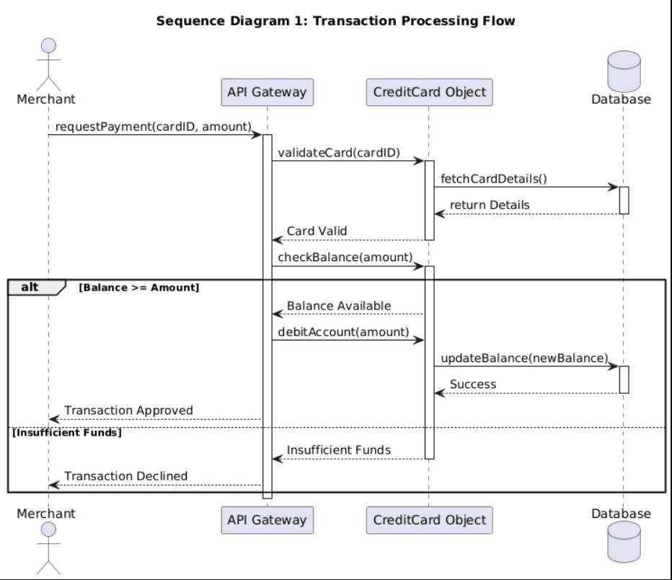
Detailed Interaction Flow:
- The Merchant initiates a charge() request.
- The System validates the card details.
- The CreditCard object checks balance >= amount.
- If valid, the Transaction object is created.
- The Database is updated, and "Success" is returned to the Merchant.\
- \
32. Alternative Flows Inclusion

Alternative Flow 1: Insufficient Funds In the Transaction Sequence, if balance < amount, the System immediately returns a "Declined" response and logs a failed attempt without modifying the database balance.
Alternative Flow 2: Fraud Alert If the transaction amount > $5000, the System triggers a FraudLog entry, blocks the transaction, and sends an alert to the Administrator.

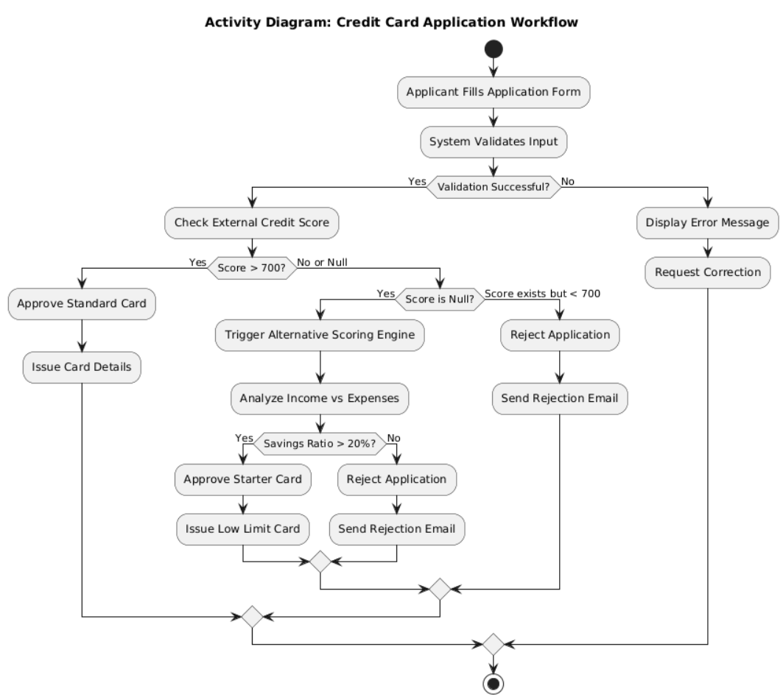

33. Activity Diagrams Creation
Activity Diagram 1: Application Workflow
Activity Diagram 2: Transaction Workflow 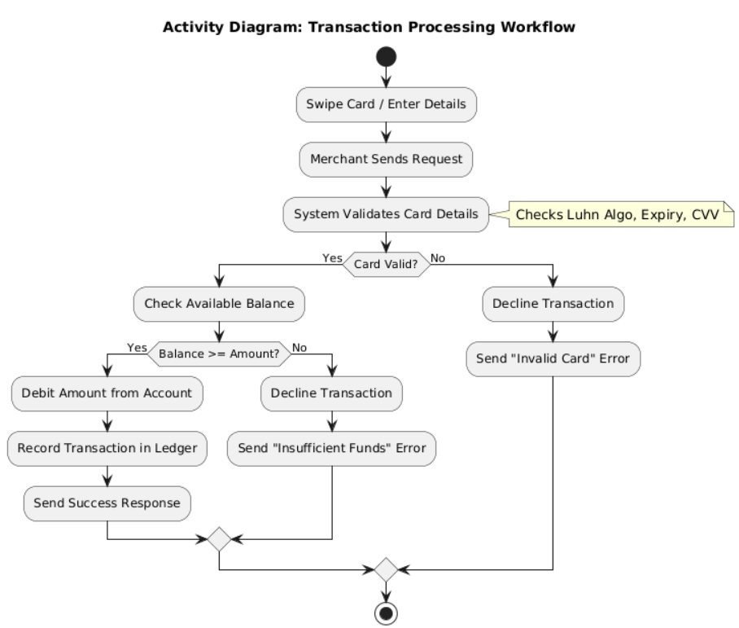

34. Workflow Documentation
Workflow 1: Hybrid Application Approval
- Applicant submits data.
- System checks External Credit Score.
- Decision Point:
  - If Score exists & is good: Instant Approval.
  - If Score is Null: Alternative Check (Income - Expenses).
  - If Cash Flow is positive: Provisional Approval.
  - Otherwise: Rejection.
- Card is issued upon Approval.
This unique workflow ensures financial inclusion for users without history.

35. Component Diagram Creation
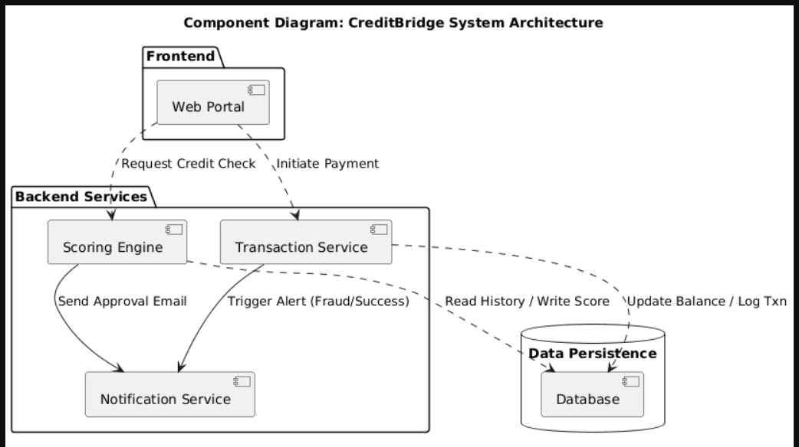
Identified Components:
- Web Portal: User Interface.
- Scoring Engine: Logic for calculating risk.
- Transaction Service: Handles payments.
- Database: Stores all records.
- Notification Service: Sends emails/SMS.

36. Deployment Diagram Creation
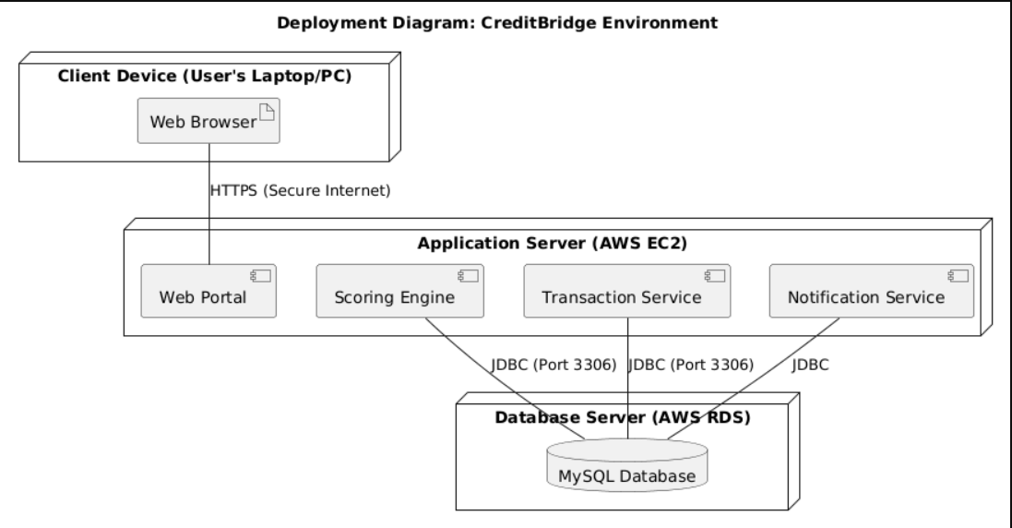
Deployment Environment:
- Client Node: User's Browser accessing the portal.
- Application Server: Hosts the Logic and API.
- Database Server: Securely stores encrypted data.
- Connection: HTTPS for security.

37. Design Document Creation
Design Decisions:
- Modular Architecture: The Scoring Engine is decoupled from the Transaction Service to allow updating risk logic without stopping payments.
- Security First: AES encryption used for storing Card Numbers in the Database.
Assumptions:
- Users have stable internet access.
- The Mock Credit Bureau API is available for testing.
Limitations:
- System does not handle real currency.
- Physical logistics are not handled.
Scalability:
- The architecture supports adding more "Merchant" nodes easily.
- Database can be scaled vertically to handle more transactions.
This design ensures CreditBridge is secure, robust, and meets the academic requirements for Software Engineering.

